Scope definition ????

Reasons of Selection Project:

We have contacted with the management of a company named “Gawsia Plastic Industries Limited” and they have proposed to build a system for them that would solve the problems they are facing now.

The reasons for we want to study the feasibilities of the project are:

1. As we have contacted with the management team directly, we have full management back up for the system development.
2. At this preliminary step, it seems that we have the capabilities to develop a system which will solve their problems and be operational within their economic and time constraints.
3. The expected system will improve the overall internal efficiency and the quality of their service. Hence it is supporting the competitive strategy of the organization. So the project is expected to be fully operational.

Problem definition:

Gawsia Plastic Industries Limited is experiencing problems with communicating with the current and potential clients, promoting their products and company in the way they expect and recruiting skilled employees.

Issues

1. They are facing troubles in promoting their products and company achievements. Adequate information about their products are not available for potential clients from home and abroad.
2. The recruitment process is not dynamic enough.
3. Client contact takes an inordinate amount of time for routine questions.
4. Potential clients are supposed to be encouraged to see a list of significant current clients but there is no suitable media to show the list.
5. Potential clients are facing problems to communicate with proper officials.
6. Clients don’t know about the technology, they use for production.

Weight

10

08

07

06

05

04

Objectives

1. Provide a section in the web system that will highlight company’s background, traditions, achievements, commitments for using eco-friendly technology. Provide search engine optimization of the website for better promotion in the web.
2. Provide a section in the website for operating recruitment process where candidates will apply for an available job and be able to know the job facilities. Information about internship and part-time jobs will be available here.
3. Provide a detailed list of product descriptions so that potential and current clients can know everything at once.
4. Provide a list of significant clients.
5. Provide an email box having some predefined subject-title so that it can be directed to the proper officials. Provide a list of high-ranking officials with contact details so that clients can contact with them individually if necessary.
6. Provide a section describing the technologies the company use for production of a specific product.

Requirements

1. The system must be secured. No irrelevant information should not be published on the website.
2. The user interface should be very easy to use.
3. There should be a section that shows bulletins about latest events.
4. There should be social network plug-ins associated to the web site.
5. New products must be highlighted significantly in the product list.
6. We must provide 1 year maintenance.

Constraints

1. The system must be ready to deploy within 12 weeks. The company want to initiate the system on the 21st Feb, 2016.
2. The company can spend at most 15,000Tk for the development purpose.

Annual maintenance cost can be at most 60,000Tk.

Feasibility Analysis

* Technical feasibility analysis:

We don’t have any existing system to upgrade to meet the clients demand.

To develop a new system we need the following technologies:

* Back-end scripting language: PHP (Laravel MVC Framework)
* Front-end scripting language: JavaScript (jQuery , Angular.js)
* UX/UI designing: HTML5, CSS3
* Database (RDBMS): MySQL server

Our development team has expertise to use these technologies. We possess all the necessary hardware and software packages required to use the technologies for the development and deployment of the system.

* Economic feasibility analysis

The company will spend:

For development of the system (Once): 12,000Tk

For maintenance of the system (Annual): 5,000Tk

Total: 17,000Tk

Our cost:

Fixed cost:

Hardware and software packages: 2,00000Tk

Variable cost:

Hosting cost (1GB/year): 1,000Tk

Domain cost (1 year): 1,000Tk

Total: 2,02000Tk

Time: 13X4 weeks or 52 weeks

Tangible benefits: 17,000Tk - 2,02000Tk = -1,85000Tk

Intangible benefits: It is an academic project and we shall gather real-life experience by developing this project.

Though in cost-benefit analysis, the project is not economically feasible, we have selected the project considering the intangible benefits.

* Operational feasibility analysis

The proposed system will solve all the problems stated above. So the system will be used once installed.

Employees of the company are using various office programs, accounts management software, web services and email services. So they know how regular systems are operated. So they will not face any problems while operating the system. Besides the user interface of the system will be very easy to use.

The system will be operationally feasible.

**Project Scheduling**

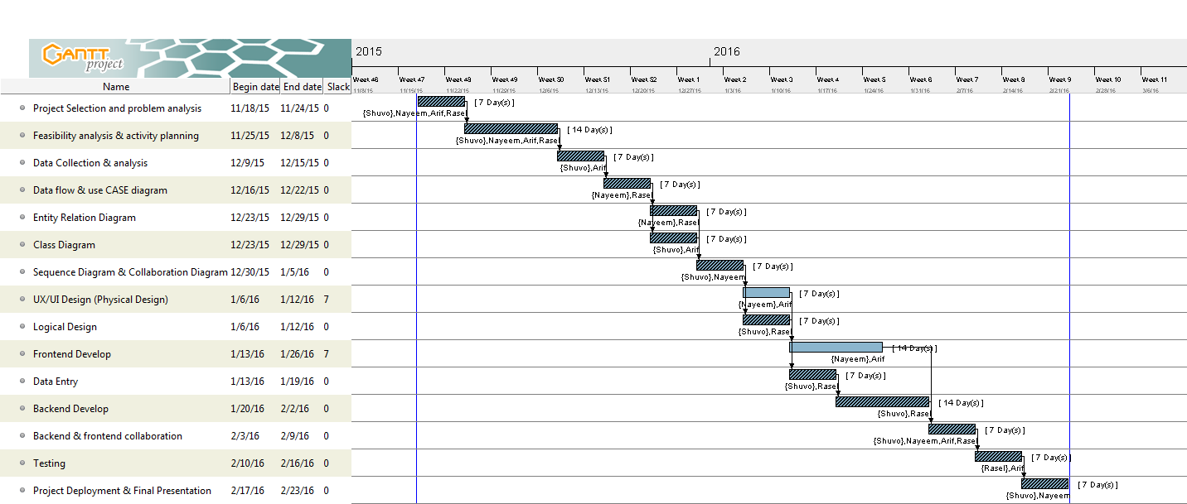Gantt chart is given below:

Resource chart is given below: 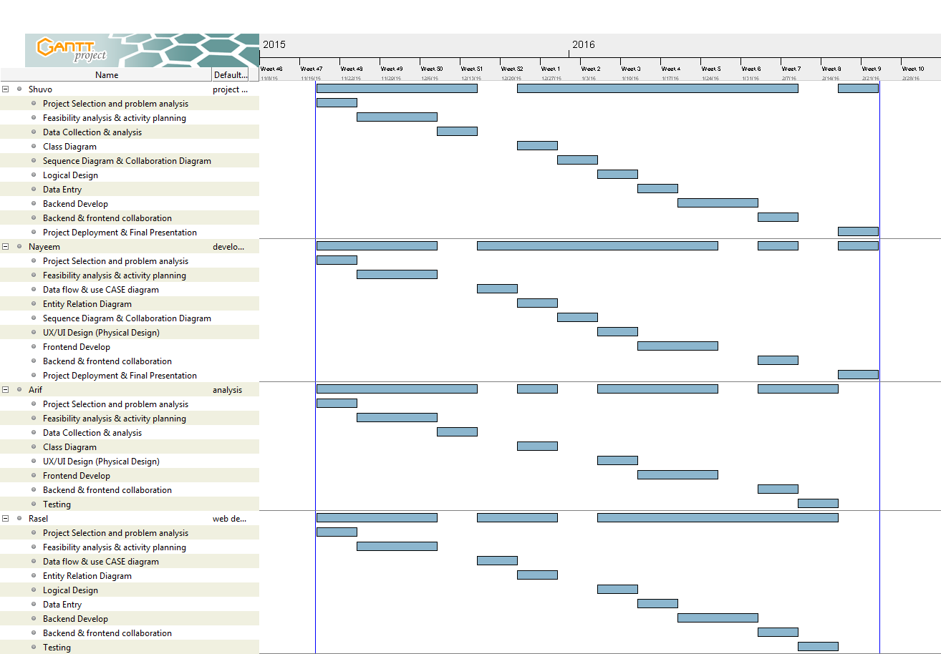

**Risk Analysis of Project**

* The system size is moderate. So the risk associated with the product size is negligible.
* Employees of the company are well educated about the operations in the regular office programs and our communication with the management team of the company is satisfactory. So risk associated with the customer characteristics is negligible.
* If any of our team members can not contribute the development process due to any personal cause, we may face problems to meet the deadline to deploy the system.
* There lies some other causes (e.g. political unrest, excessive load shading and lack of internet connectivity) that creates the uncertainty to meet the deadline.
* The system will promote products quality and company achievements. And we shall gain real-life experience by completing the project. So the business impact is positive.

**Conclusion**

The proposed system is proved to be feasible in the feasibility analysis. s